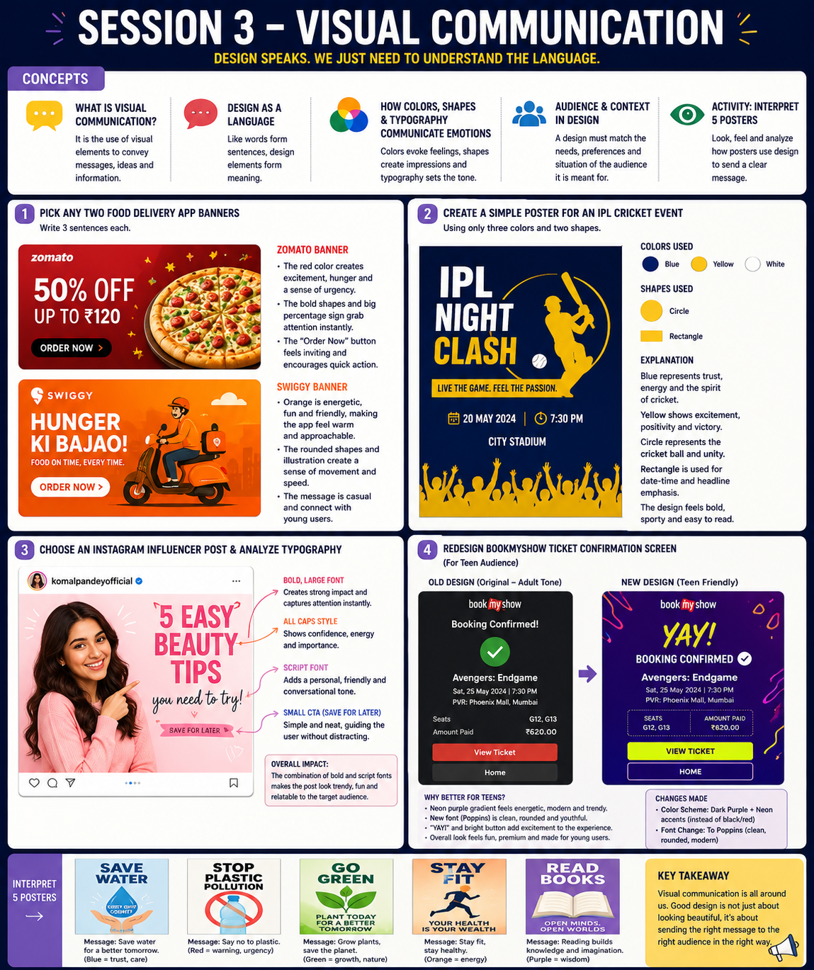SESSION 3 – Visual Communication Explanation
1. Food Delivery App Banners Analysis
Zomato Banner
- The red color creates excitement, hunger, and urgency, encouraging users to order food quickly.
- Large discount text grabs attention immediately and highlights the offer.
- The circular pizza image looks appealing and makes the food the main focus.
Swiggy Banner
- Orange creates a friendly, energetic, and warm feeling.
- The delivery rider illustration suggests speed and convenience.
- Rounded shapes make the design feel approachable and user-friendly.

2. IPL Cricket Event Poster
Colors Used:
- Blue
- Yellow
- White
Shapes Used:
- Circle
- Rectangle
Explanation:
- Blue represents trust, confidence, and the spirit of sports.
- Yellow symbolizes energy, excitement, and celebration.
- The circle represents a cricket ball and movement, while the rectangle organizes information clearly.
- Using only three colors keeps the design simple and visually effective.

3. Instagram Influencer Typography Analysis
The influencer post uses different font styles to communicate the message:
- Large bold text ("5 EASY BEAUTY TIPS") immediately attracts attention.
- Capital letters create confidence and importance.
- Script-style text adds a personal and friendly feel.
- Smaller call-to-action text guides viewers without distracting from the main message.
Overall Impact:
The typography creates a fun, youthful, and engaging mood that appeals to social media audiences.

4. BookMyShow Ticket Confirmation Screen Redesign
Changes Made:
- Replaced dark red and black colors with purple and neon yellow.
- Changed the font to a modern rounded style.
Why It Works Better for Teenagers:
- Purple represents creativity and individuality.
- Neon yellow feels energetic and trendy.
- Rounded fonts look friendly and modern.
- The brighter color palette creates a fun and exciting experience compared to the more formal adult version.

5. Poster Interpretation Activity
Save Water Poster
Message: Water is precious and should be conserved for future generations.
Stop Plastic Pollution Poster
Message: Reduce plastic usage to protect the environment.
Go Green Poster
Message: Plant trees and support eco-friendly habits.
Stay Fit Poster
Message: Exercise regularly to maintain good health.
Read Books Poster
Message: Reading improves knowledge, imagination, and learning.

Conclusion
Visual communication uses colors, shapes, images, and typography to deliver messages without needing many words. Effective design helps communicate emotions, attract attention, and connect with the intended audience.

